SEG Awards Level 2

Motor Vehicle Studies

Underpinning Knowledge Evidence Record

K/601/6030 Knowledge of Removing and Fitting Electrical Components

Learners Name
SEG Awards Registration Number
Centre Name
Assessor 1 Name
Assessor 2 Name

DECLARATION OF AUTHENTICITY

This declaration must be completed and signed by the learner and countersigned by the tutor / assessor and covers all evidence submitted for moderation.

Learner Name
Unique Learner Number (ULN) |  | SEG  Learner Reg. ID
Qualification Title
Centre Name

Learner statement of authenticity

Before signing please read the guidance below.

I confirm, that the attached assignment / portfolio is all my own work and does not include any work completed by anyone other than myself. I have completed the assignment / portfolio in accordance with SEG Awards’ instructions and within the time limits set by my centre.

Signature |  | Date

Centre confirmation of authenticity

On behalf of …………………………………….(insert centre name), I confirm that the above mentioned learner, to the best of my knowledge, is the sole author of the completed assignment / portfolio attached, and the assessments have been completed under the required conditions.

Signed |  | Date
Name
Title

Guidance for Learners

You have been asked to sign this Declaration of Authenticity and place it at the front of your portfolio or course work assessment. It confirms that the work you have submitted for assessment is your own and that you have not copied it from someone else or allowed another learner to copy it from you.

When preparing any course work it is good practice to undertake research using information from published sources. If you quote directly from these sources then this must be indicated in your work by using quotation marks and referencing the document from which the quotation was taken. You must then comment in your own words on any ideas expressed.

Assessors, internal verifiers and SEG Awards’ external moderators and verifiers are subject specialists who can spot the use of published materials that may be passed as your own words or ideas.
If you do copy words from a published source and do not indicate their reference you will be committing plagiarism. This is considered a form of cheating and may result in your assessment being declared void.

Contents

Task No | Title | Assessment Criteria
1 | Removing and fitting electrical components | 1.1, 1.2, 1.3, 1.4, 1.8
2 | Head lamps | 1.5, 1.6, 1.7
3 | Component construction and operation | 2.1, 2.2

Task 1 – Removing and fitting electrical components | Assessment Criteria 1.1, 1.2, 1.3, 1.4, 1.8

Explain the procedure for reporting damage to vehicle electrical components and units
Identify components to be removed and re-fitted | Remove  And  Re-fit | Sources of Information Used
 |  | Manual | Autodata | Thatcham eScribe | Internet | Other  (State)
Batteries
Headlamp units
Starter motor
Alternator
Door lock actuator/motor
Window motor
Wiper/washer motor
Explain the procedures involved in the removal and refitting of the selected components
(if this component is a gas discharge headlamp system please include any special precautions or procedures)
Identify the procedure involved in working with, and fitting supplementary safety systems (e.g. SRS, Airbag)
After removal please state the procedure for correct storage of the Supplementary Safety System (SRS) components

Task 2 – Head lamps | Assessment Criteria 1.5, 1.6, 1.7

Headlamp Adjustment
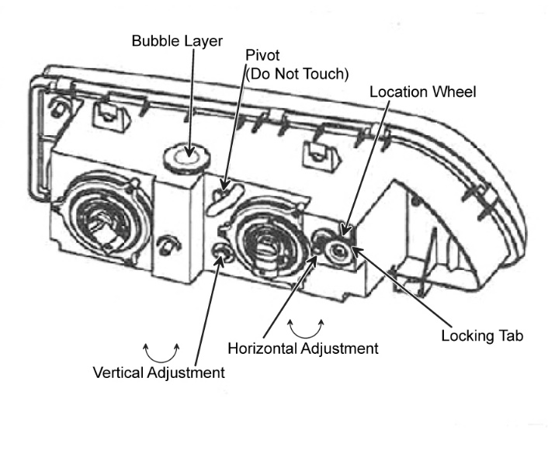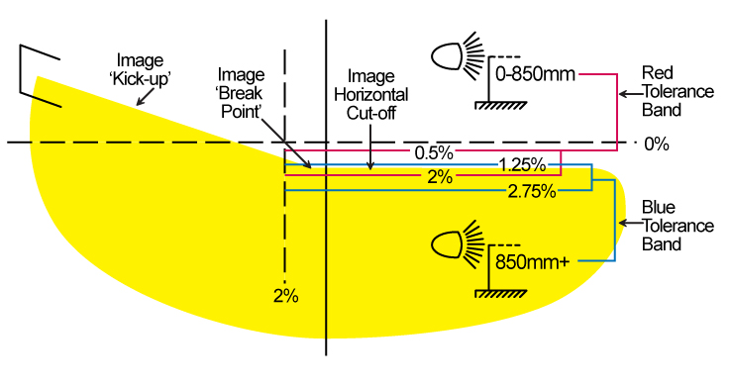

Alignment and Quality Checks
Explain the following:
How to correctly align chosen components
Reasons for correct alignment
List the quality checks and procedures associated with this task
Identify correct conformity of vehicle systems against vehicle specification (e.g. legal requirements of lighting systems)

Task 3 – Component construction and operation | Assessment Criteria 2.1, 2.2

Briefly describe the construction and basic operation of the following components
Batteries
Headlamp units
Starter motor
Alternator
Door lock actuator/motor
Window motor
Wiper/washer motor

Unless otherwise stated e.g. for some entry level qualifications, learners can work together but should identify sections which are their own work.

